**Using Electrical Library of Simulink:**

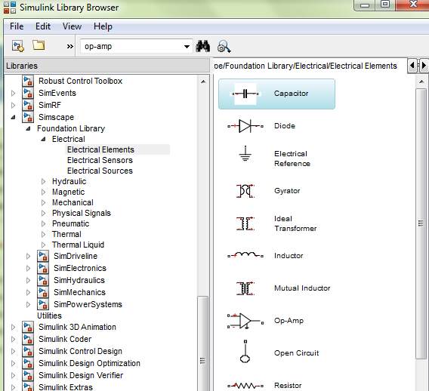

**Important Points:**

* Solver Configuration should be connected to reference of the circuit
* In order to measure voltage and currents, “voltage sensor” or “current sensor” are used. The output of these sensors is connected to display or scope via “PS-simulink” converter.

**Example – 1: Simulating RC Circuit in Simulink:**

*V=5volts, R=1 ohm, C=1F*

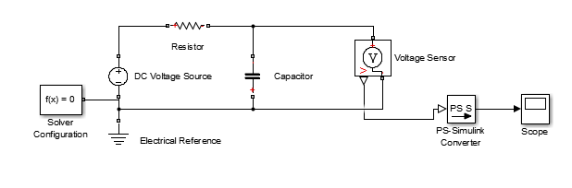

During animation, double click on scope to see the graph

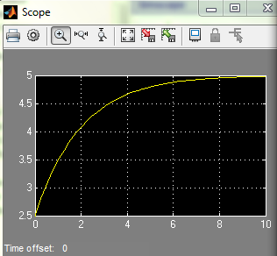

**Simulating Operational Amplifier circuit in MATLAB**

***Example – 2:* Non inverting amplifier circuit where Vin = 1, Rf=10, Ri = 2**

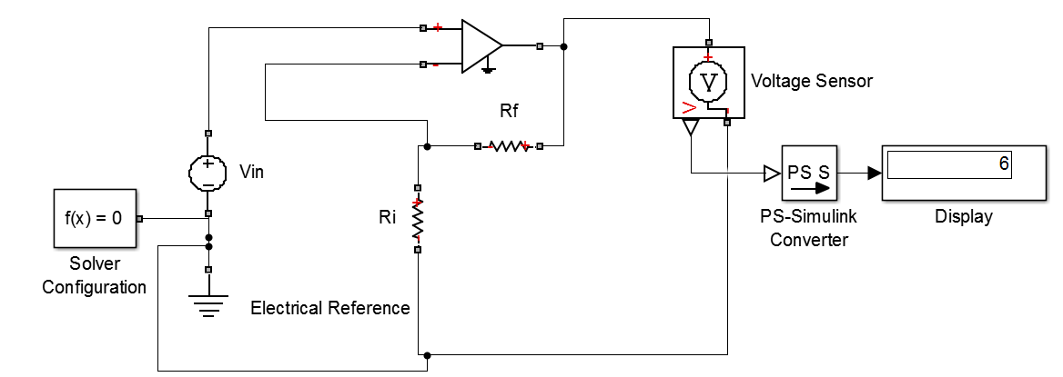

***Example3:* Inverting amplifier circuit where AC Vin = 1, Rf=10, Ri = 2**

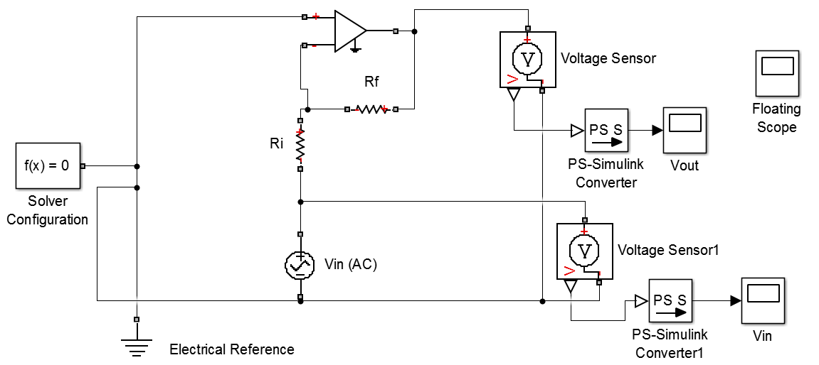

|  |  |
| --- | --- |
| **Using Floating Scope:** In order to display more than one signals on single scope, we may use floating scope. Place this scope anywhere on the page. Double click on it a blank screen will appear: |  |

Right click on it and select “signal selection”.

Check the required outputs of “PS-Simulink converter”

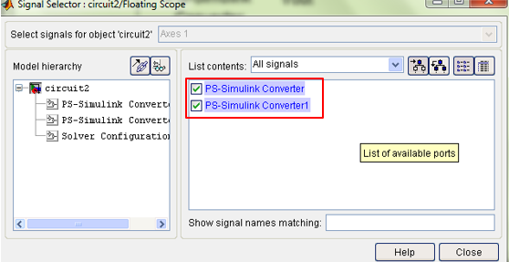

|  |  |
| --- | --- |
| Press simulate again | If |

**If the floating scope is Not Working on your matlab then:**

Search Mux from your search library. Drag and drop Mux (signal routing) from library to your model.

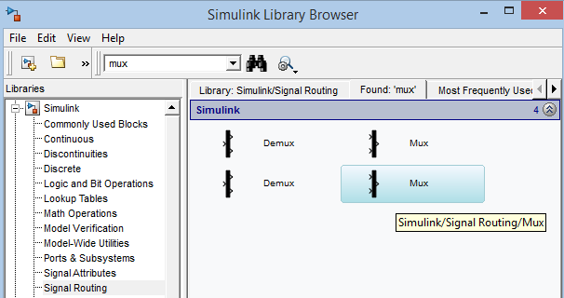

Connect the output of mux with a scope. The inputs of the MUX should be connected with the output of PS-Simulink Converters.

**For example**

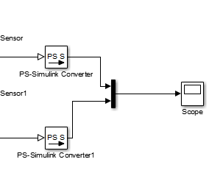

Mux takes both signals and shows them on the same scope.

***Example4:* Operational amplifier as an Integrator:**

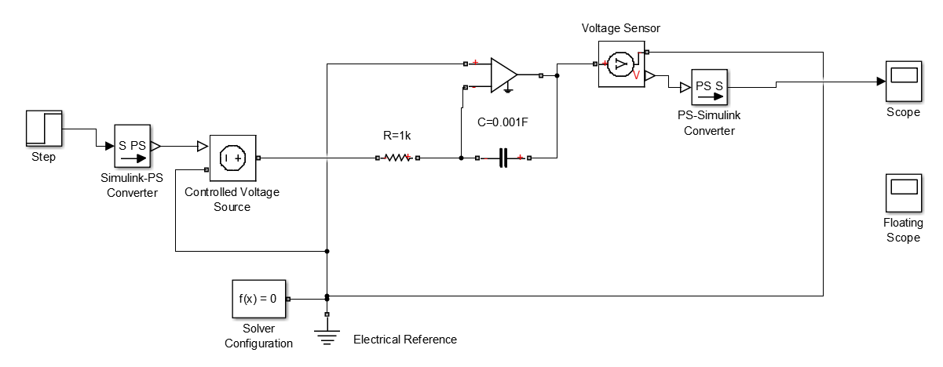

Step Signal Properties:

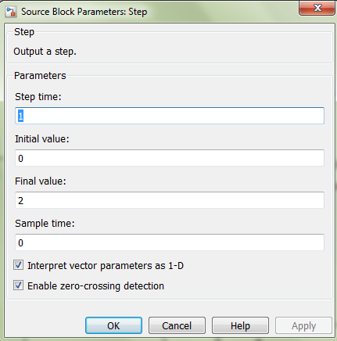

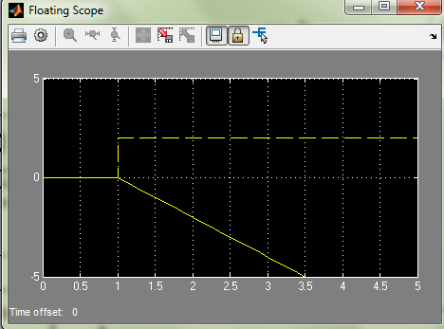

***Example5:* Operational amplifier as a Differentiator:**

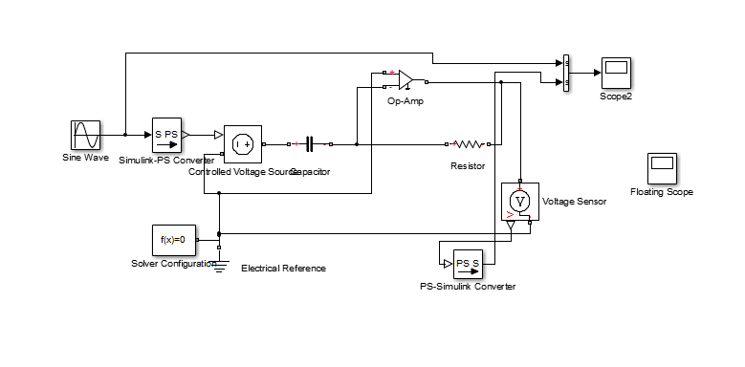

Signal Generator Properties:

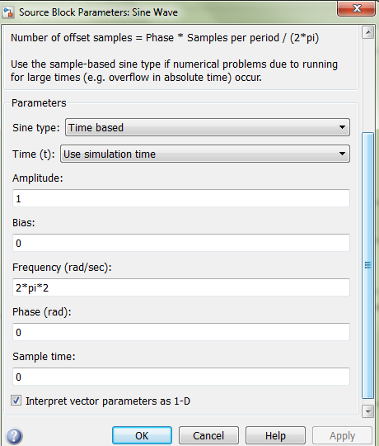

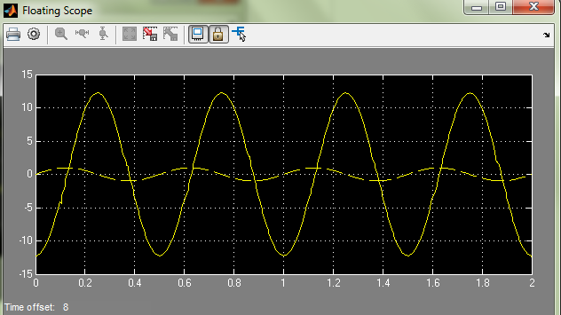

***Example6:* Half Wave Rectification**

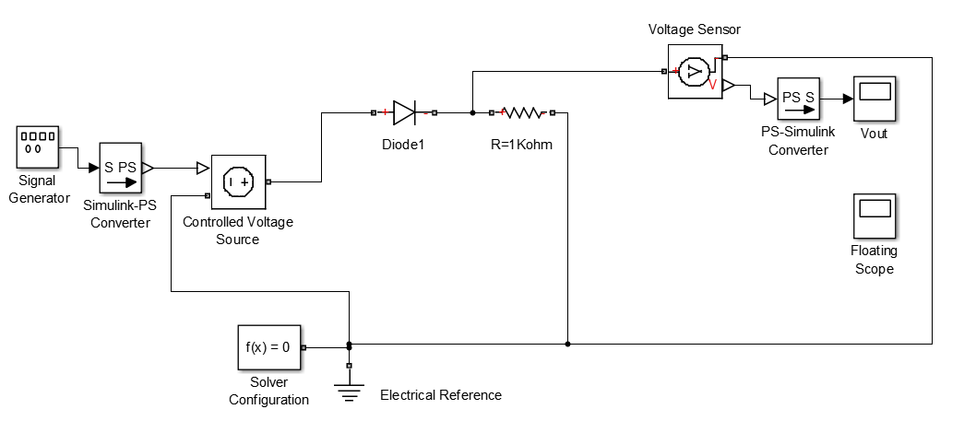

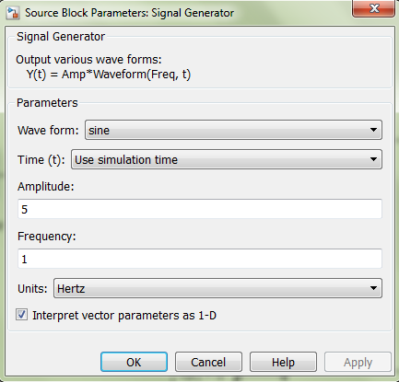

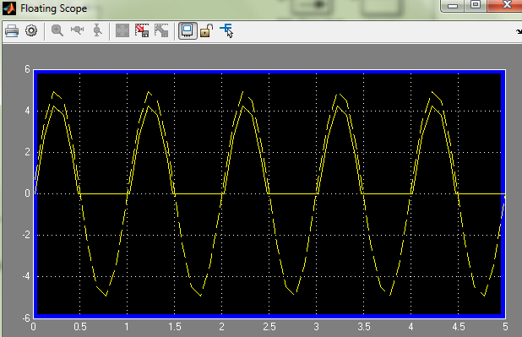

***Example7:* Full Wave Rectification**

